Automation of rule creation through Excel sheets

Version: 0.3

Date: 6th April 2020

Written by: Security Department

CON-460

CON-456

CON-459

# Rationale

This document covers an analysis for creating an Excel document which will partially replace the IriusRisk rule editor, providing an easier way to create Drools files. This is because HSBC is looking for a way to automate rules creation with Excel without using the IriusRisk rule editor GUI.

# Requirements

The Excel sheet must have the ability to define the following attributes

* Conditions
  + Component Definition
  + Question is answered
  + Question Group exists
* Actions
  + Insert question group
  + Insert question
  + Import risk pattern

These attributes should be selectable from *combobox* components to provide consistency for the user. After the sheet has been completed, a Python script will do the conversion to an IriusRisk XML rule library.

The conditions and actions listed above were specifically selected so that HSBC can easily perform the most common customisations:

1. Check if the component is a specific one
2. Add a new Question group to the questionnaire
3. Add new questions to the questionnaire
4. Cause a Risk Pattern to be imported based on a question answered in the questionnaire.

The initial release of the excel will include only these conditions and will only allow use of the “component” module, not the dataflow module.

# Sheet model

We present an option to construct the Excel file based on three sheets.

Example:

I want to create a new QuestionGroup:

1. Goto Rules sheet, create new rule, select module
2. Goto Conditions sheet, select rule, select condition, provide condition options.
3. Goto Actions sheet, select rule, select action provide action options

* **Sheet 1: Rules**

|  |  |
| --- | --- |
| Rule name | Module type (selectable) |
| Create a question group | component |
| Ask question about something | component |
| Import risk pattern depending on answer | component |

* **Sheet 2: Conditions**

|  |  |  |  |  |
| --- | --- | --- | --- | --- |
| Rule name (selectable) | Condition (selectable) | <Question is answered Condition Value> | <Question Group exists Condition Value> | <Component Definition Condition value> |
| Ask question about something | Question Group exists |  | QuestionGroupID |  |
| Import risk pattern depending on answer | Question Group exists |  | QuestionGroupID |  |
| Import risk pattern depending on answer | Question is answered | QuestionID |  |  |
| Import risk pattern depending on answer | Component Definition |  |  | ComponentID |

Rule name is selectable from the Sheet 1.

* **Sheet 3: Actions**
  + **Sheet where actions options have one column per attribute and they are grouped under its action definition:**

In this case the number of columns can vary depending on the selected action.

|  |  |  |  |  |  |  |  |  |
| --- | --- | --- | --- | --- | --- | --- | --- | --- |
|  |  | Insert Question Options | | | Insert Question Group Options* | | Import Risk Pattern | |
| Rule name | Action | QuestionID | QuestionOption | Description | QuestionGroupID | Category... | LibraryID** | RiskPatternID** |
| Create a question group | Insert Question Group |  |  |  | QuestionGroupID | Category |  |  |
| Ask question about something | Insert Question | QuestionID | Value | “Description of the question” |  |  |  |  |
| Import risk pattern depending on answer | Import Risk Pattern |  |  |  |  |  | LibraryID | RiskPatternID |
|  |  |  |  |  |  |  |  |  |

Rule name is selectable from the Sheet 1.

*Insert Question Group Options has more attributes, this is just an example.

**This attributes should be selectable

## Selectable attributes

Attributes that are selectable are defined in the Lists sheet and the Risk Patterns sheet.

# Practical Example: Defining rules in Excel

In the following section we’ll illustrate some examples about the different IriusRisk conditions and actions modeled (for the component module) using a first version of the Excel file to build IriusRisk rules.

First we need to specify the Library Name, Ref and Description for the library that will be created as a result of the conversion process.

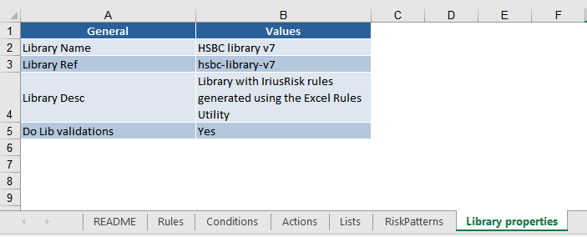

Secondly, for each rule we need to set the “Rule Name” and the “module type” as “component” in “Rules” worksheet (we currently only support *component* Rule module types):

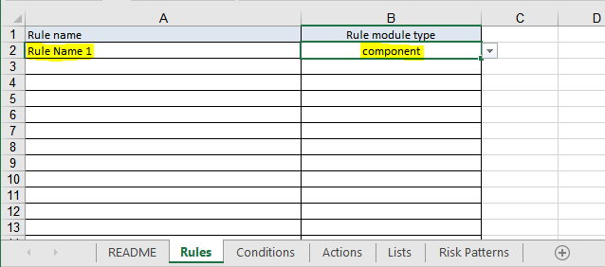

## Conditions

### Component Definition

“Component definition” condition is illustrated with the following example in IriusRisk Rules Editor:

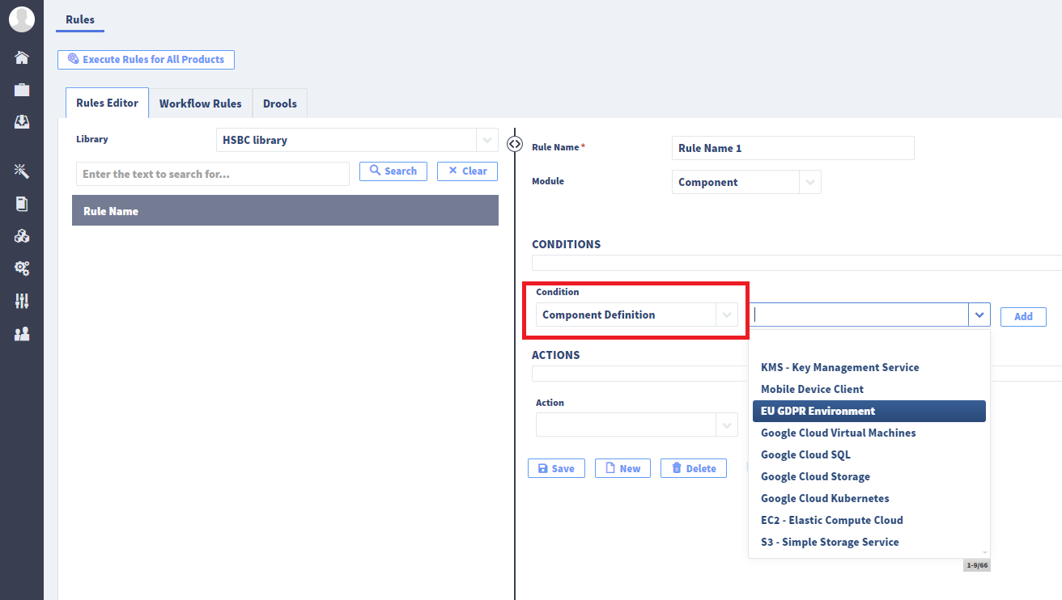

The equivalent condition modeled in the Excel view (“Conditions” worksheet) would be:

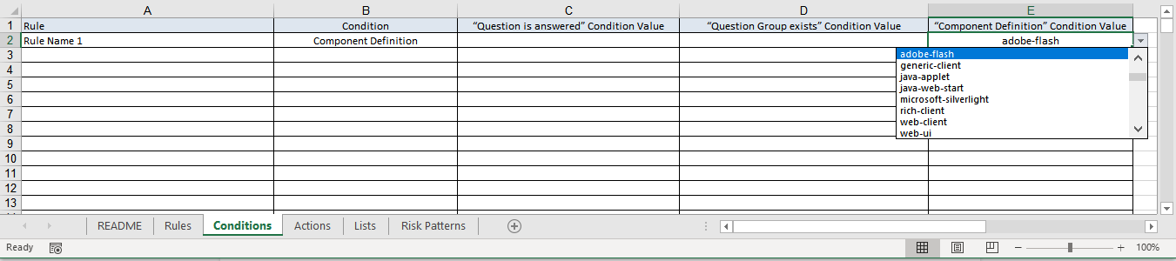

### Question is answered

“Question is answered” condition is illustrated with the following example in IriusRisk Rules Editor:

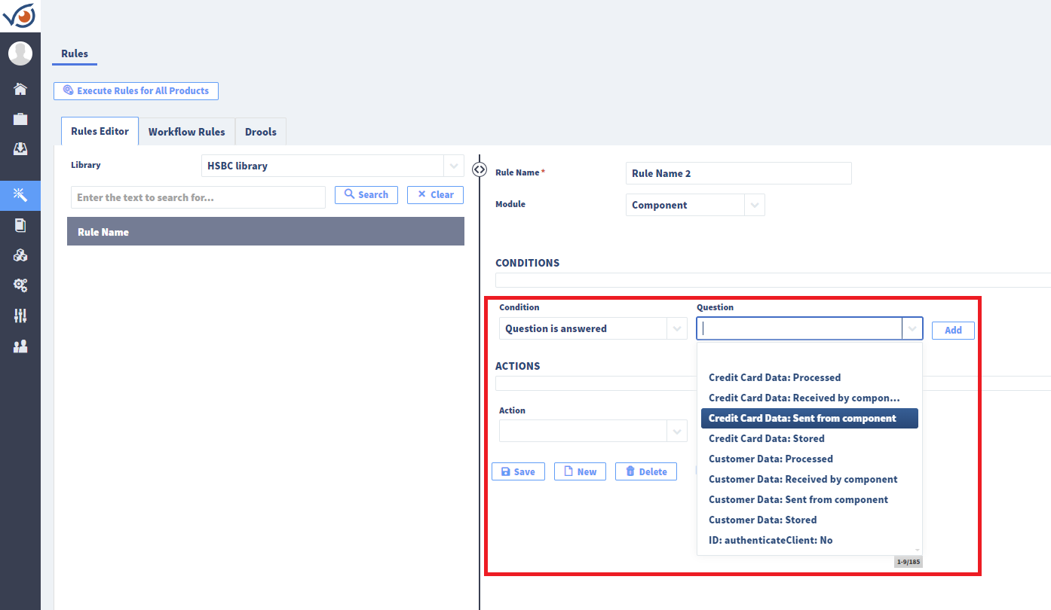

The equivalent condition modeled in the Excel view (“Conditions” worksheet) would be:

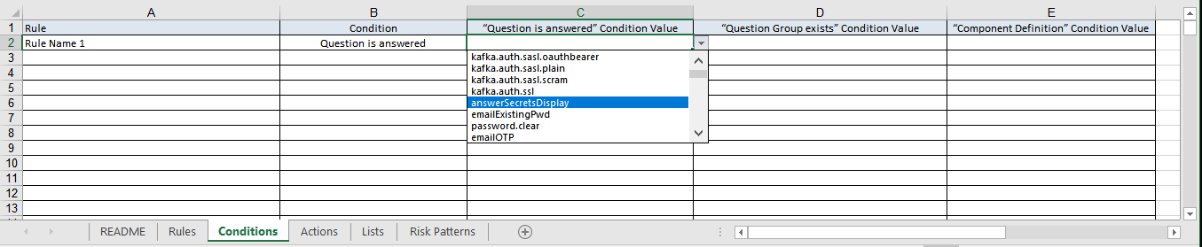

### Question Group exists

“Question group exists” condition is illustrated with the following example in IriusRisk Rules Editor:

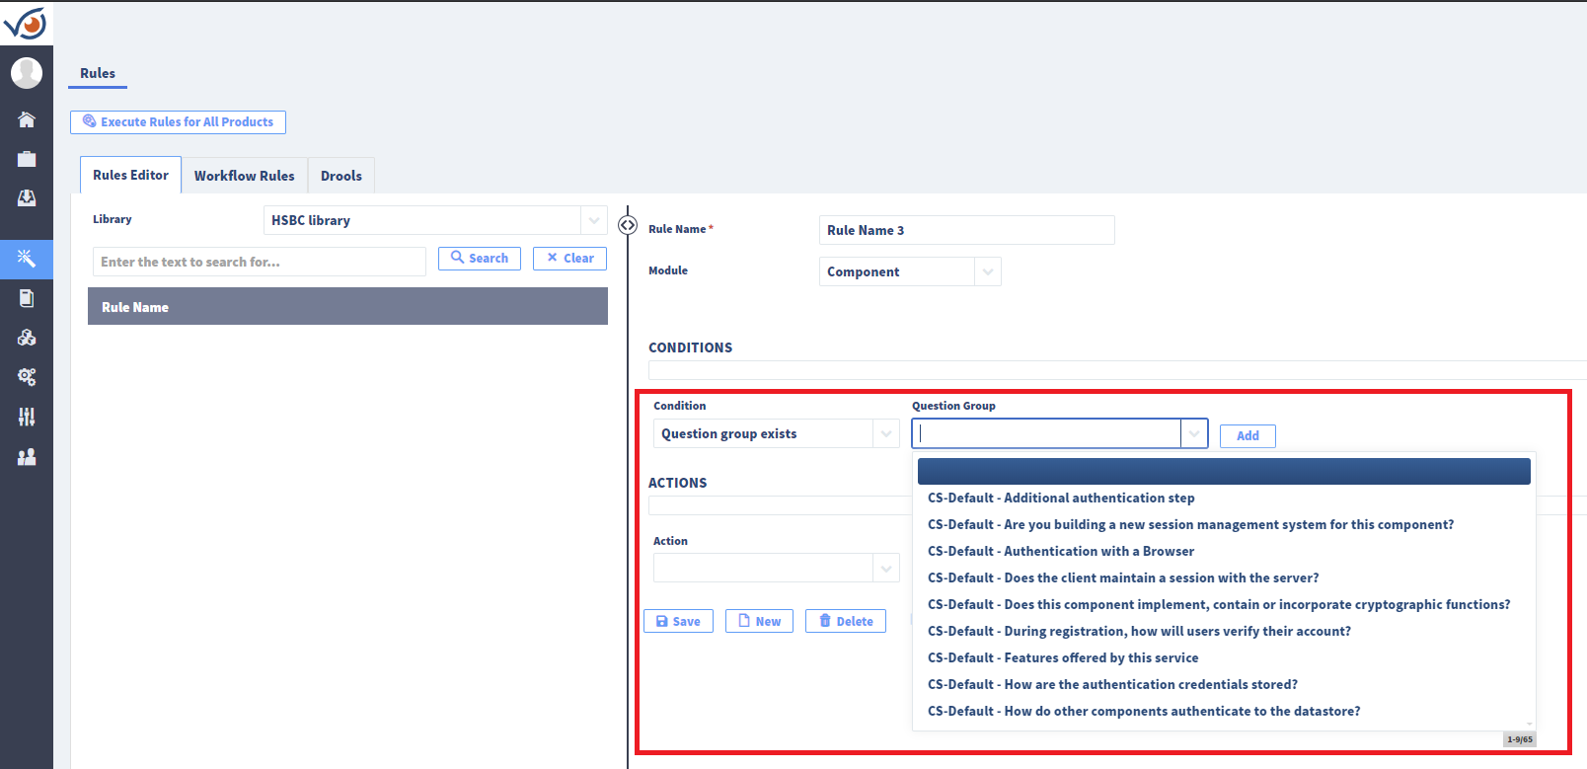

The equivalent condition modeled in the Excel view (“Conditions” worksheet) would be:

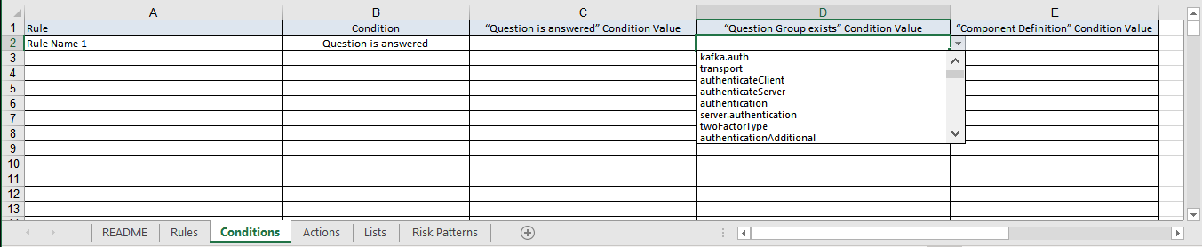

## Actions

### Insert question group

“Insert question group” action is illustrated with the following example in IriusRisk Rules Editor:

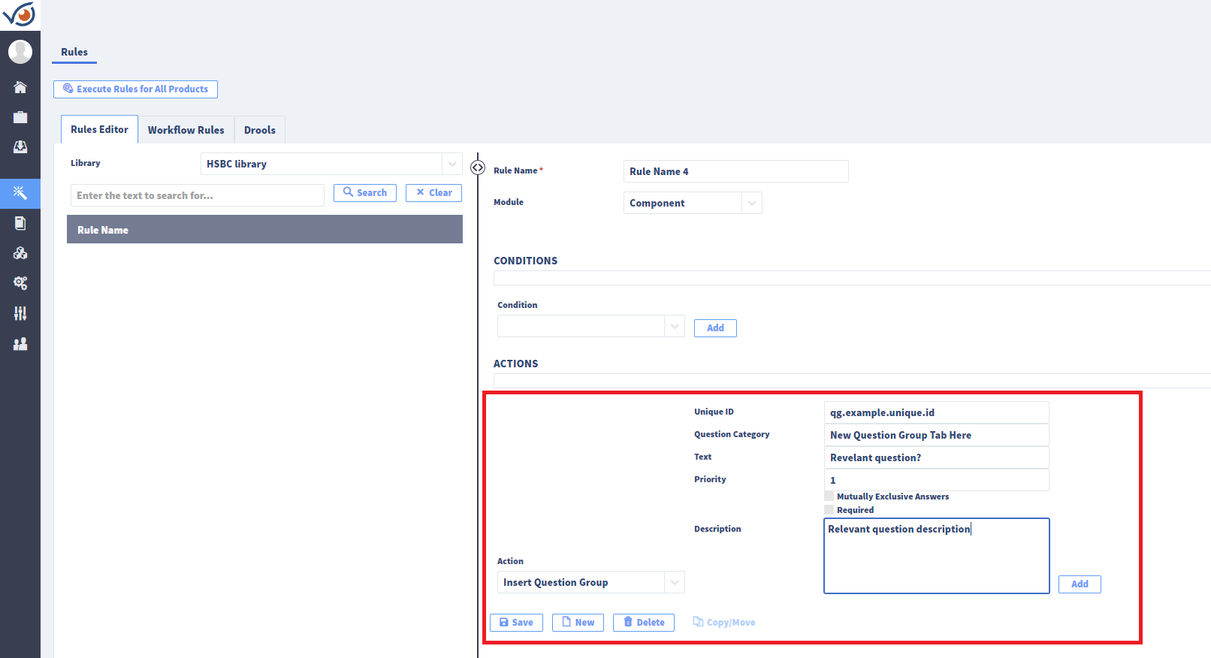

The equivalent action modeled in the Excel view (“Actions” worksheet) would be:

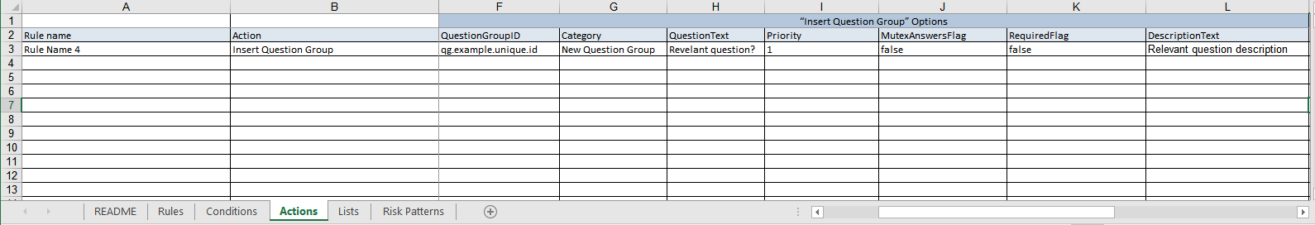

### Insert question

“Insert question” action is illustrated with the following example in IriusRisk Rules Editor:

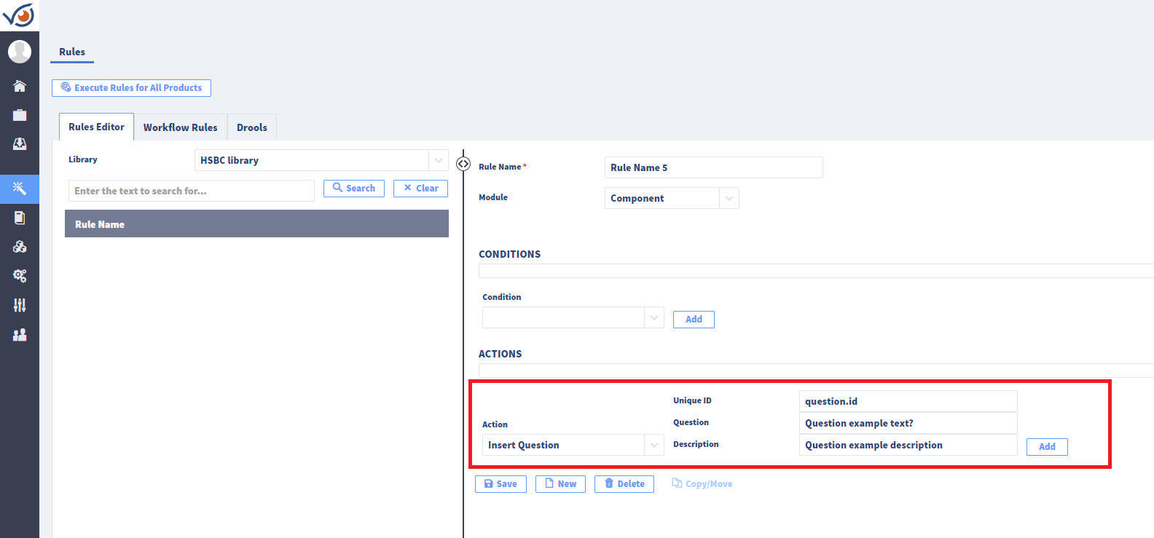

The equivalent action modeled in the Excel view (“Actions” worksheet) would be:

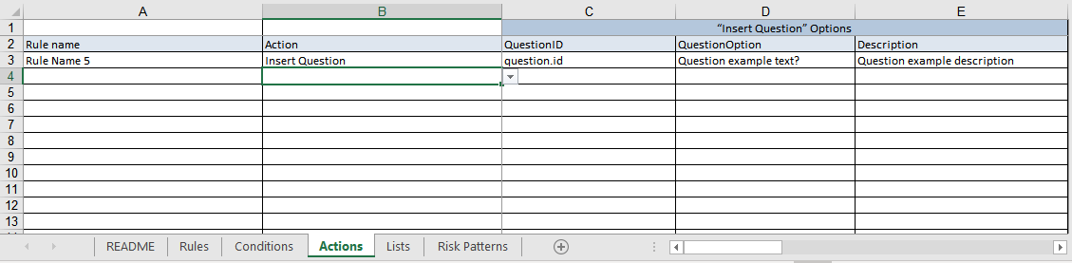

NOTE: Questions can only be inserted if a question group is selected in the condition

### Import risk pattern

“Import risk pattern” action is illustrated with the following example in IriusRisk Rules Editor:

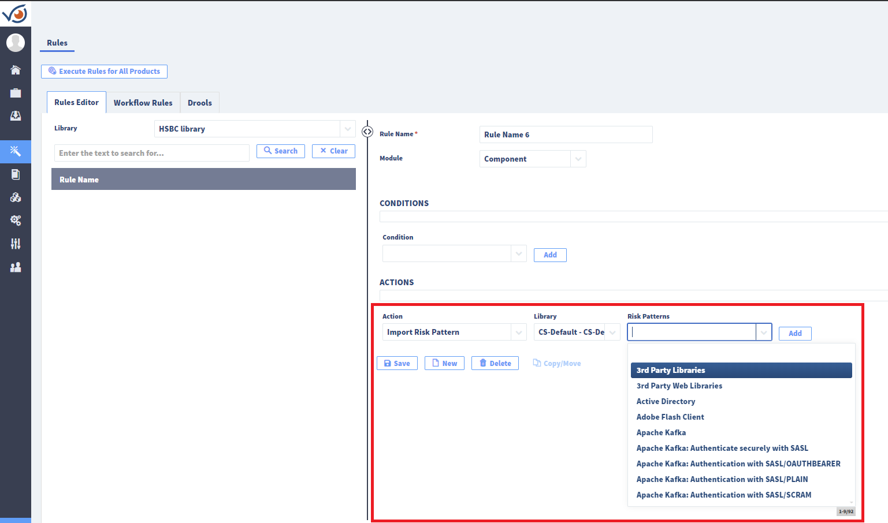

The equivalent action modeled in the Excel view (“Actions” worksheet) would involve first selecting the library (“LibraryID”) for the risk pattern we want to import:

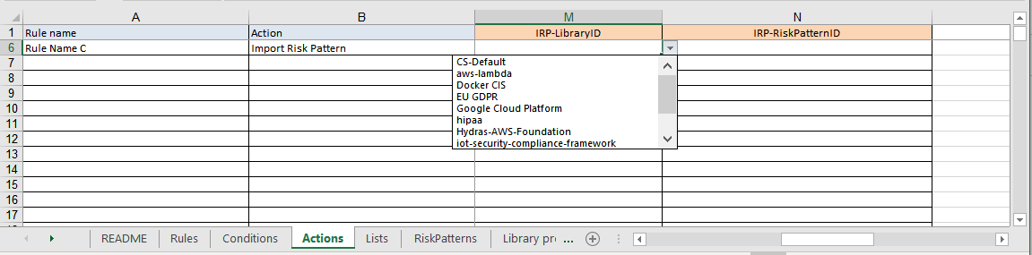

And then select the Risk Pattern (“RiskPatternID”):

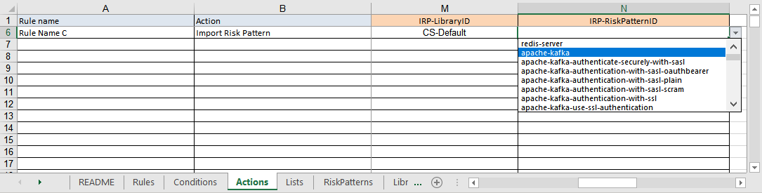

# Practical Example: Run the conversion script

Once we’ve defined the rules in the Excel file to build IriusRisk rules we can use IriusRiskToolKitUI to generate those rules in an XML format inside an IriusRisk library.

IriusRiskToolKitUI is a Python GUI client for working with several common tasks regarding security content management in IriusRisk platform.

## IriusRiskToolKitUI Installation

IriusRiskToolKitUI is tested in Python version 3.7.3. Python should have the dependencies for tcl/tk. You can test this requirement with the following command:

|  |
| --- |
| python -m tkinter |

Use the package manager pip to install the needed dependencies for IriusRiskToolKitUI to run.

|  |
| --- |
| pip install lxml  pip install xlrd  pip install pandas  pip install openpyxl  pip install textile  pip install pyyaml  pip install requests  pip install requests-toolbelt  pip install PySimpleGUI |

## IriusRiskToolKitUI Usage

To launch the application you should run the following command:

|  |
| --- |
| python3 IriusRiskToolKitUI.py |

You’ll see the following interface:

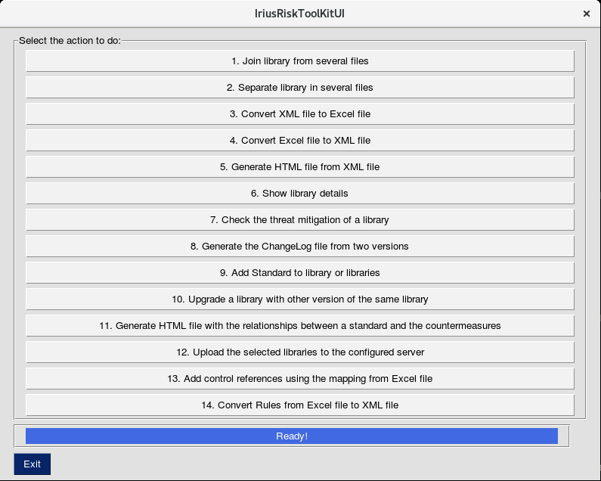

## Convert IriusRisk rules from Excel using IriusRiskToolKitUI

To start the process to convert the IriusRisk Rules Creator Worksheet to a IriusRisk XML library you should click on *14. Convert Rules from Excel file to XML file* button.

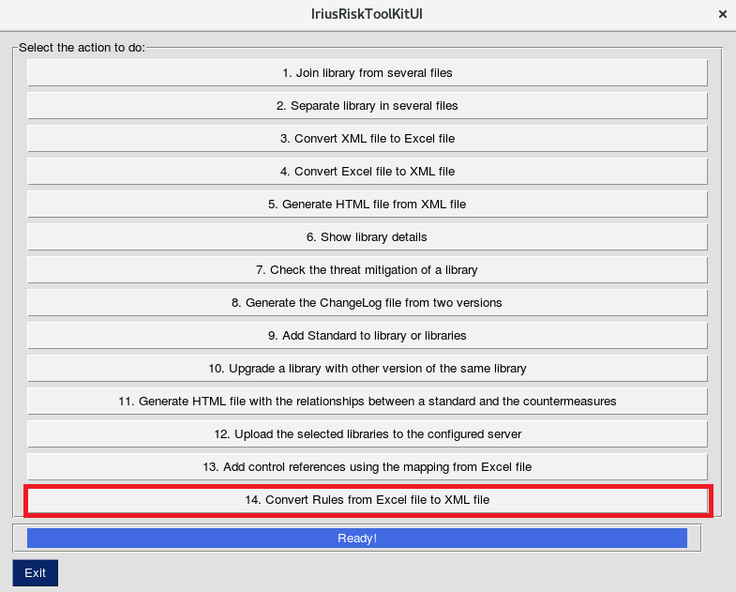

Then you’ll see the following dialog.

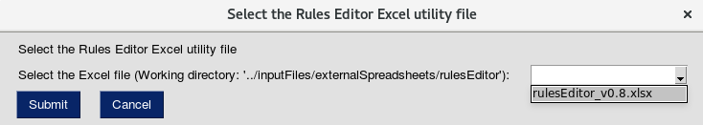

You should select the Excel file where the rules are stored and click on the *Submit* button.

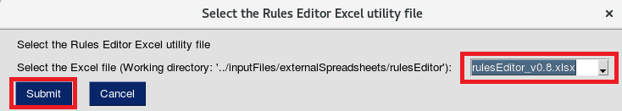

At the end of the process we should see the following window:

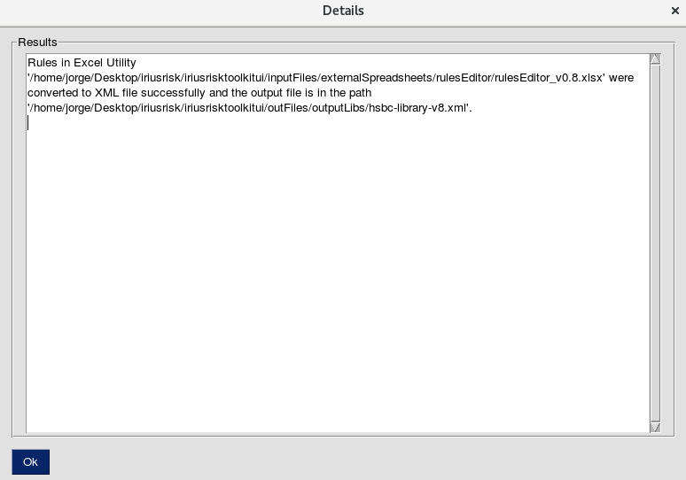

The created XML Library file should be in the path:

|  |
| --- |
| iriusrisktoolkitui/outFiles/outputLibs/[Library-Ref].xml |

In the logFile.log file you can see a summary of the process involved:

